
Department of Information Technology

ONLINE STUDENT ATTENDANCE MANAGEMENT SYSTEM

Submitted in partial fulfilment of the requirements for the degree of

BACHELOR OF TECHNOLOGY
In
INFORMATION TECHNOLOGY
Submitted By

Team Members

<<TIMES NEW ROMAN ; SIZE 14>>

Under the Guidance of

Mrs.C.Manonmani

SRM TRP ENGINEERING COLLEGE
Academic Year: 2026-27 (ODD)

Department of Information Technology

CERTIFICATE

This is to certify that “<< team members details>>from second year IT has successfully completed her work titled “Mini Project Title” at SRM TRP Engineering, Trichy in the partial fulfillment of the Bachelor’s of Technology in Information Technology.

Mrs.C.Manonmani |  | Dr.
(Faculty In-charge) |  | (Head of Department)
Artificial Intelligence & Data Science |  | Information Technology |  | Computer Engineering

ACKNOWLEDGEMENT

It is with sincere gratitude and deep appreciation that I take this opportunity to acknowledge the invaluable support and guidance I have received throughout the course of this project. This journey has been both intellectually enriching and personally rewarding, significantly enhancing my understanding of the subject and its practical applications. I would like to express my heartfelt thanks to all those who provided guidance, encouragement, and constructive feedback during the development of this project. Their insights and support were instrumental in shaping the direction and quality of the work. I also extend my appreciation to the department for fostering an environment that promotes learning, innovation, and academic growth. The resources and opportunities provided played a vital role in the successful completion of this project. A special note of thanks goes to the supporting staff for their cooperation and timely assistance, which ensured that the process remained smooth and efficient at every stage. Finally, I would like to express my deepest gratitude to my parents for their constant support, encouragement, and belief in my abilities. Their motivation has been a source of strength throughout this journey. This project has not only strengthened my knowledge but has also emphasized the importance of dedication, perseverance, and continuous learning. I remain sincerely thankful to everyone who contributed, directly or indirectly, to the successful completion of this project.

Academic Year: 2026-2027
<< Team Members>>

TABLE OF CONTENTS

Sr. No | Title | Page No.
1 | Acknowledgement…………………………………………… | 3
2 | Abstract ………………………………………………......... | 5
3 | Introduction…...……………………………………………... | 6
4 | System Requirements ………………………………………. | 7
5 | System Design………………………………………………… | 8
6 | Implementation……………………………………………… | 13
7 | Testing…….……………………………………………. | 14
8. | Result and Conclusion ……………………………………. | 17
9. | References……………………………………………………. | 17

ABSTRACT

The Online Student Attendance Management System is a web-based application designed to simplify and automate the process of recording and managing student attendance in educational institutions. Traditional attendance systems rely on paper registers, which require considerable time and effort and may lead to errors or loss of records.
This system provides a digital platform for teachers to mark attendance, maintain student details, and generate attendance reports. Administrators can manage student information, class details, and teacher accounts. Students can view their attendance records and monitor their attendance percentage.
The application can be developed using HTML, CSS, JavaScript, PHP, and MySQL. HTML and CSS are used to design the user interface, JavaScript provides client-side interactivity, PHP handles server-side operations, and MySQL stores student and attendance information.
The main objective of this project is to reduce manual work, improve accuracy, save time, and provide easy access to attendance records through a centralized web application.

INTRODUCTION

Introduction: Online Student Attendance Management System
Attendance management is an important activity in schools, colleges, and other educational institutions. Maintaining accurate attendance records helps institutions monitor student participation and identify students with low attendance.
In the traditional method, teachers record attendance manually in registers. Calculating attendance percentages and preparing monthly or semester reports can be time-consuming. Manual records may also be damaged, misplaced, or incorrectly maintained.
The Online Student Attendance Management System provides a convenient and efficient solution to these problems. It allows authorized users to access attendance information through a web browser.

1.1 Objectives
To automate the student attendance recording process.
To maintain student details in a centralized database.
To allow teachers to mark attendance online.
To calculate attendance percentages automatically.
To generate daily, monthly, and semester-wise reports.
To reduce paperwork and manual calculation errors.
To provide secure access to attendance information.

1.2 Scope of the Project
The system can be used by schools, colleges, and other educational institutions. It supports student registration, teacher access, attendance entry, attendance report generation, and student attendance monitoring.
The system can be expanded in the future with features such as QR-code attendance, email notifications, mobile access, and biometric integration.

SYSTEM REQUIREMENTS

System Requirements
System requirements specify the hardware and software needed to develop and operate the application.
2.1 Hardware Requirements
Processor: Intel Core i3 or equivalent and above.
RAM: Minimum 4 GB.
Storage: Minimum 10 GB of available space.
Monitor: Standard display.
Input devices: Keyboard and mouse.
Network: Internet or local network connection, depending on deployment.
2.2 Software Requirements
Operating System: Windows, Linux, or macOS.
Frontend: HTML5, CSS3, and JavaScript.
Backend: PHP.
Database: MySQL.
Web Server: Apache.
Development Environment: XAMPP or an equivalent PHP development environment.
Browser: Google Chrome, Mozilla Firefox, Microsoft Edge, or another modern
browser.
2.3 Functional Requirements
User login and authentication.
Student registration and profile management.
Teacher account management.
Class and subject management.
Daily attendance marking.
Attendance record modification by authorized users.
Attendance percentage calculation.
Attendance report generation.
Student attendance viewing.
Logout and session management.

SYSTEM DESIGN

System Design: Online Student Attendance Management System (ex:architecture diagram)
The methodology of this project focuses on designing and implementing a deep learning-based system capable of predicting gender and age from facial images. The approach follows a structured pipeline that includes data collection, preprocessing, model design, training, evaluation, and deployment. By leveraging convolutional neural networks (CNNs), the system learns to extract meaningful facial features and perform both classification (gender) and regression or classification (age) tasks. The methodology ensures that the model is trained efficiently and produces accurate predictions in real-world scenarios.
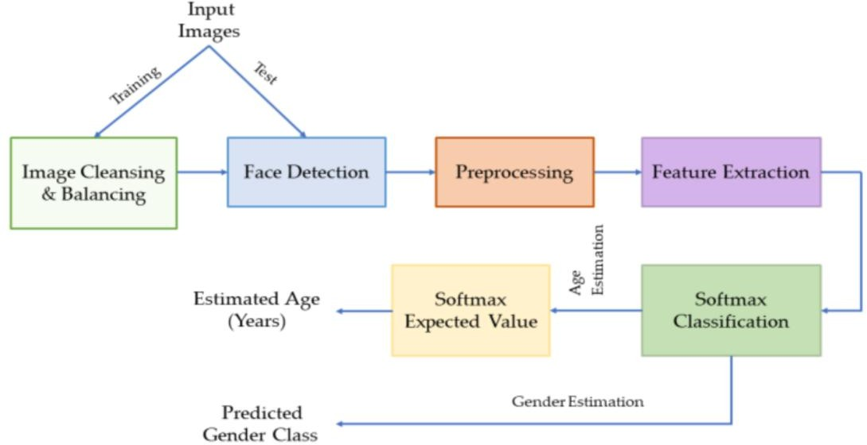

Overall System Workflow
The workflow begins with collecting and preprocessing facial images, followed by training a CNN model. The trained model is then used to predict gender and age for new input images. Each stage plays a critical role in ensuring the accuracy and robustness of the system.

Data Collection and Dataset Selection
The first step involves selecting a suitable dataset that contains labeled facial images with corresponding gender and age information. Popular datasets such as UTKFace and Adience are commonly used due to their diversity and real-world variations. These datasets include images with different ages, genders, ethnicities, lighting conditions, and facial expressions, which help the model generalize effectively.
Key dataset characteristics:
- Large number of labeled facial images
- Diversity in age groups and gender distribution
- Variations in pose, lighting, and background
- Real-world conditions for better generalization
A well-balanced dataset is essential to avoid bias and improve model performance.

Data Preprocessing
Before feeding the data into the model, preprocessing is performed to ensure consistency and improve learning efficiency. Since deep learning models are sensitive to input format, all images must be standardized.
Key preprocessing steps include:
- Face Detection: Using OpenCV to detect and crop facial regions
- Resizing: Converting images to a fixed size (e.g., 64×64 or 128×128 pixels)
- Normalization: Scaling pixel values (e.g., between 0 and 1)
- Data Augmentation: Applying transformations such as rotation, flipping, and zooming
These steps help improve model robustness and prevent overfitting.

Model Architecture Design

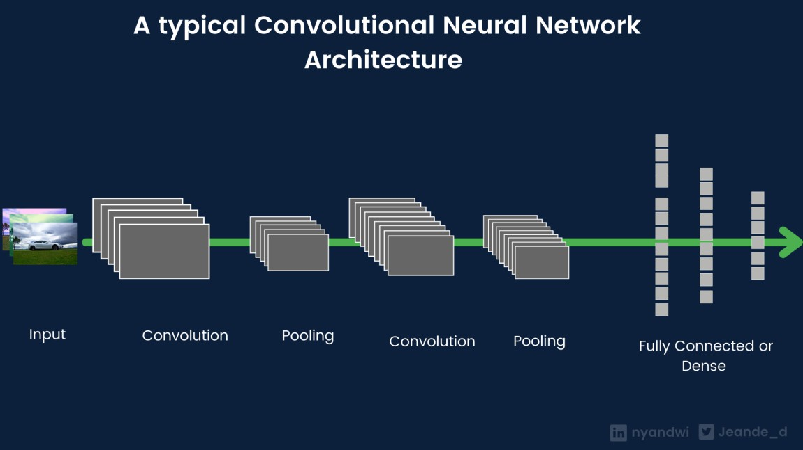

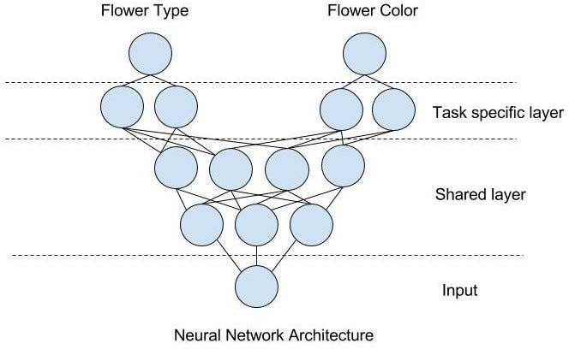

The core of the system is a convolutional neural network (CNN) designed to extract features from facial images. The architecture typically consists of multiple convolutional layers followed by pooling layers and fully connected layers. The model uses a multi-task learning approach, where shared layers extract features, and separate output layers handle gender and age prediction.
Model components:
- Convolutional Layers: Extract spatial features (edges, textures, patterns)
- Pooling Layers: Reduce dimensionality and computational cost
- Fully Connected Layers: Learn high-level representations

Output Layers:
  - Gender → Binary classification (male/female)
  - Age → Regression or multi-class classification
This design allows the model to efficiently learn both tasks simultaneously.

Model Training
The model is trained using the preprocessed dataset, where it learns to map input images to corresponding gender and age labels. The dataset is divided into training, validation, and testing sets to ensure proper evaluation and avoid overfitting.
Key training components:

Loss Functions:
  - Binary Cross-Entropy for gender classification
  - Mean Squared Error (MSE) or Categorical Cross-Entropy for age
- Optimizer: Adam optimizer for efficient gradient descent

- Batch Size & Epochs: Tuned based on dataset size and performance
- Regularization: Dropout layers to prevent overfitting
During training, the model updates its weights through backpropagation to minimize prediction error.

Model Evaluation

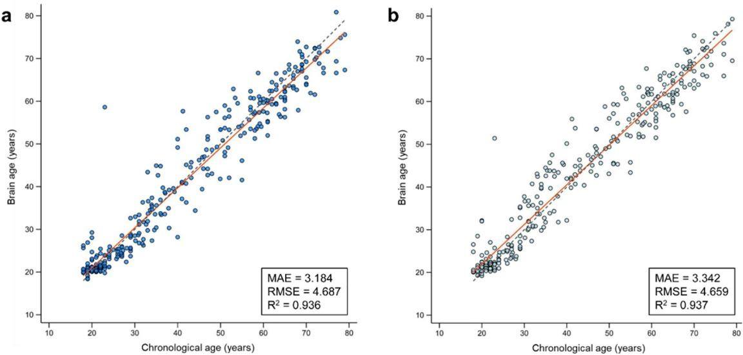
After training, the model is evaluated using the test dataset to measure its performance.
Different metrics are used for gender and age prediction:
- Gender Prediction: Accuracy, Precision, Recall, F1-score
- Age Prediction: Mean Absolute Error (MAE), Mean Squared Error (MSE)
Visualization tools such as confusion matrices and training curves are used to analyze performance and identify potential improvements.

Prediction and Deployment
Once the model is trained and evaluated, it can be used for real-time predictions. Given a new facial image, the system performs preprocessing, extracts features using the CNN, and outputs predicted gender and age.
Steps involved:
- Input image capture
- Face detection and preprocessing
- Model inference
- Display predicted gender and age

The model can be integrated into applications such as surveillance systems, mobile apps, or web-based platforms.

Challenges and Optimization
Some challenges encountered in this project include:
- Variability in facial features due to age and ethnicity
- Lighting and image quality issues
- Imbalanced dataset distribution
- Difficulty in precise age prediction
To overcome these challenges, techniques such as data augmentation, transfer learning, and hyperparameter tuning can be applied.

IMPLEMENTATION

Output as expected is as follows

Implementation involves converting the system design into a working web application.
4.1 Frontend Development
HTML is used to create pages such as the login page, dashboard, student registration
form, attendance form, and reports page.
CSS is used to style the pages and create a consistent layout. JavaScript can be used
for form validation, confirmation messages, and interactive dashboard elements.
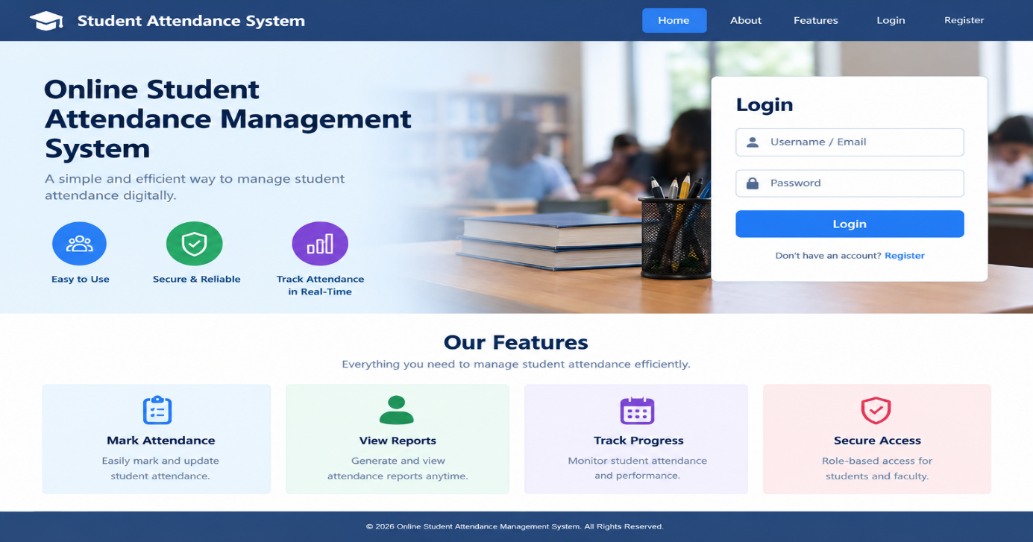
4.2 Backend Development
PHP is used to process user requests, authenticate users, retrieve student details,
record attendance, calculate attendance percentages, and generate reports.
All user inputs must be validated on the server. Database operations should use
prepared statements to reduce SQL injection risks.

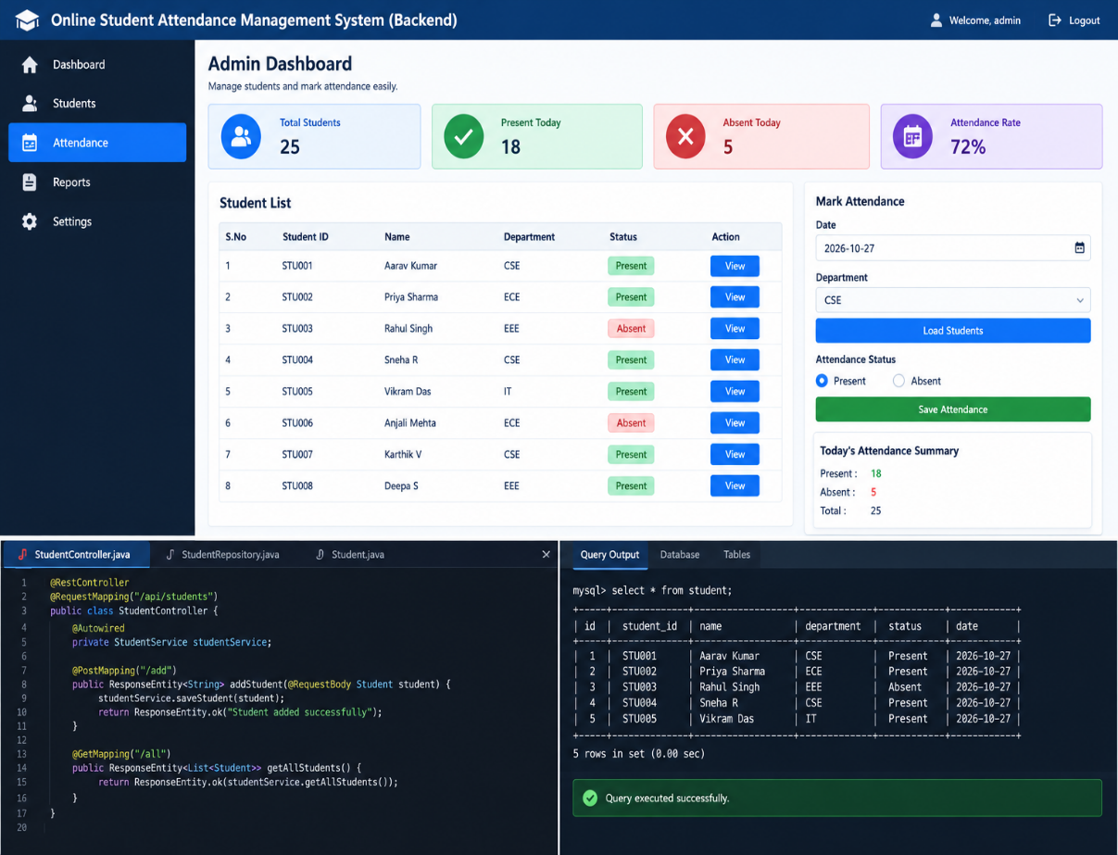
4.3 Database Implementation
MySQL is used to store and organize application data. Tables are linked using
primary keys and foreign keys. This structure reduces unnecessary duplication and
maintains relationships between students, classes, subjects, and attendance records.
OUTPUT SCREEN SHOT

4.4 Attendance Recording
The teacher selects a class, subject, and attendance date. The application displays the l
ist of students in that class. The teacher marks each student as present or absent and
submits the form.
The server validates the submitted information and saves the attendance records in the
database. Authorized users can review or correct records when necessary.
4.5 Report Generation
The system retrieves attendance records based on the selected student, class, subject,
or date range. It calculates the number of classes attended and the total number of
classes held, then displays the corresponding attendance percentage.
Reports can optionally be provided in printable format or exported as PDF or CSV
files.
4.6 Security Implementation
Passwords should be stored as secure password hashes.
User sessions should be managed securely.
Role-based authorization should restrict access to administrative, teacher, and student
functions.
Prepared statements should be used for database queries.
Input validation and output escaping should be implemented.
Attendance modifications should be restricted to authorized users.

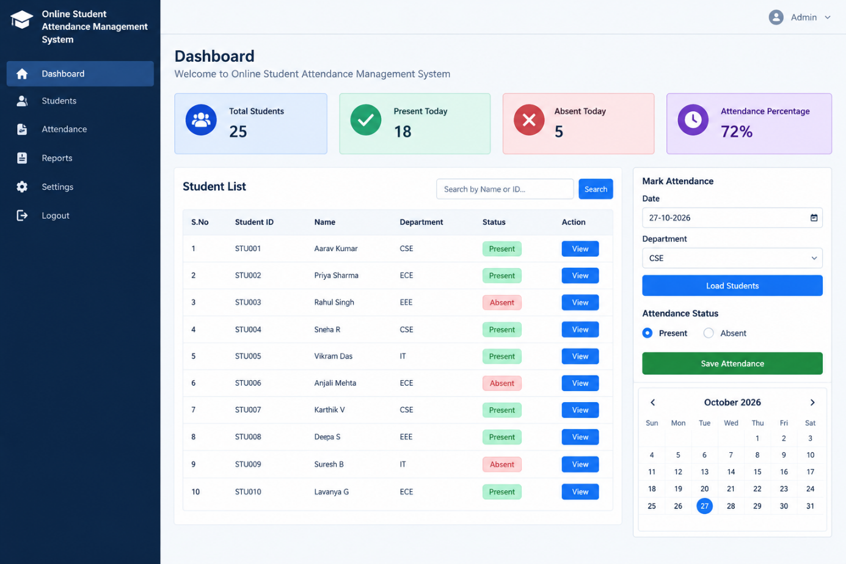

TESTING

Testing is performed to verify that the application functions correctly and meets the specified requirements.
5.1 Types of Testing
Unit Testing: Individual functions, such as login validation and attendance
percentage calculation, are tested separately.
Integration Testing: The interaction between PHP, MySQL, and the user interface is
tested.
System Testing: The complete application is tested to verify the main workflows.
Security Testing: Authentication, authorization, input validation, and database query
handling are checked.
Usability Testing: The application is checked for ease of navigation and clarity of
information.
5.2 Test Cases
Test Case 1: Valid Login
Input: Correct username and password.
Expected Result: The user is redirected to the appropriate dashboard.
Test Case 2: Invalid Login
Input: Incorrect username or password.
Expected Result: An error message is displayed, and access is denied.
Test Case 3: Student Registration
Input: Valid student details.
Expected Result: The student record is saved successfully.
Test Case 4: Attendance Marking
Input: A valid class, subject, date, and attendance status.
Expected Result: Attendance records are saved in the database.
Test Case 5: Duplicate Attendance
Input: An attempt to record attendance twice for the same student, subject, and date.
Expected Result: The duplicate record is rejected or handled according to the
application's update policy.
Test Case 6: Attendance Percentage
Input: A student attended 36 out of 40 classes.
Expected Result: The attendance percentage is displayed as 90%.
Test Case 7: Attendance Report
Input: A valid student or date range.
Expected Result: The system displays the corresponding attendance records and
summary.
Test Case 8: Unauthorized Access
Input: A student attempts to access an administrator-only page.
Expected Result: Access is denied.
The final test results should be recorded after executing the test cases in the developed
application.

RESULT AND CONCLUSION

- The Online Student Attendance Management System is designed to make attendance recording and reporting easier, faster, and more reliable. It provides a centralized platform for managing student information, recording attendance, calculating attendance percentages, and viewing reports.
- The application reduces dependence on paper registers and minimizes errors associated with manual calculations. It also enables teachers and administrators to retrieve attendance information efficiently while allowing students to monitor their attendance records.
- The project demonstrates the practical use of web technologies such as HTML, CSS, JavaScript, PHP, and MySQL in developing an educational management application.
- In conclusion, the system offers an effective approach to digital attendance management. After successful implementation and testing, it can be deployed in an educational institution and further enhanced with QR-code scanning, biometric devices, mobile notifications, and cloud-based access.

REFERENCES

- UTKFace Dataset (Age, Gender, Ethnicity Dataset) https://susanqq.github.io/UTKFace/
- Adience Dataset (Age and Gender Classification Benchmark) https://talhassner.github.io/home/projects/Adience/Adience-data.html
- TensorFlow Official Documentation https://www.tensorflow.org
- PyTorch Official Documentation https://pytorch.org
- OpenCV Documentation https://docs.opencv.org
- Deep Learning Book – Ian Goodfellow, Yoshua Bengio, Aaron Courville https://www.deeplearningbook.org
- CNN Architecture Explanation https://www.geeksforgeeks.org/convolutional-neural-network-cnn/
- Facial Analysis using Deep Learning (Research Overview) https://ieeexplore.ieee.org/document/age-gender-detection

